**.Assignment 8**

**Name**: Jeevan Sai Badana

**Mail**: [jeevansai100@gmail.com](mailto:jeevansai100@gmail.com)

**Date**: 30-01-2024

Topic: CSV

**File IO using python**

**Reading from a file**

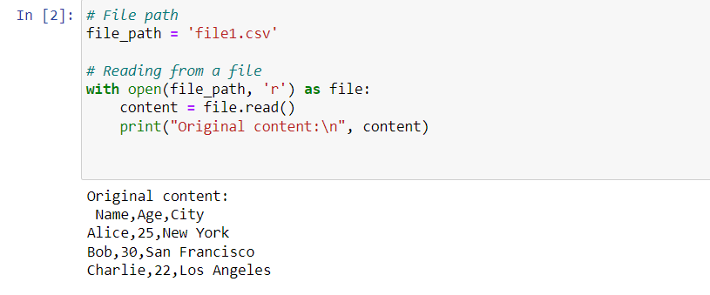

**Modify content to upper letters**

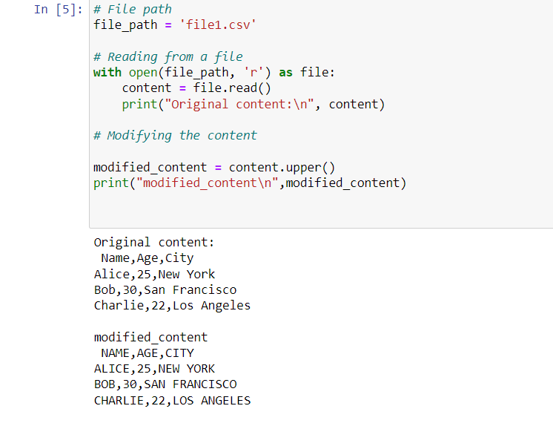

**Writing content to file**

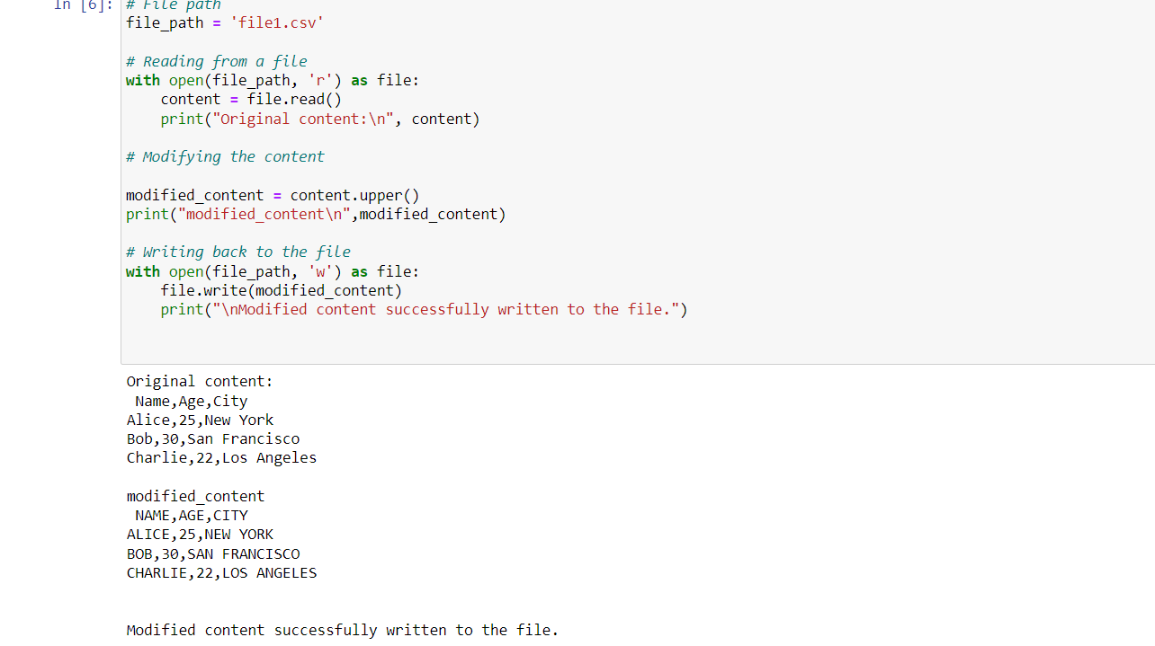

**Reading and printing the modified content**

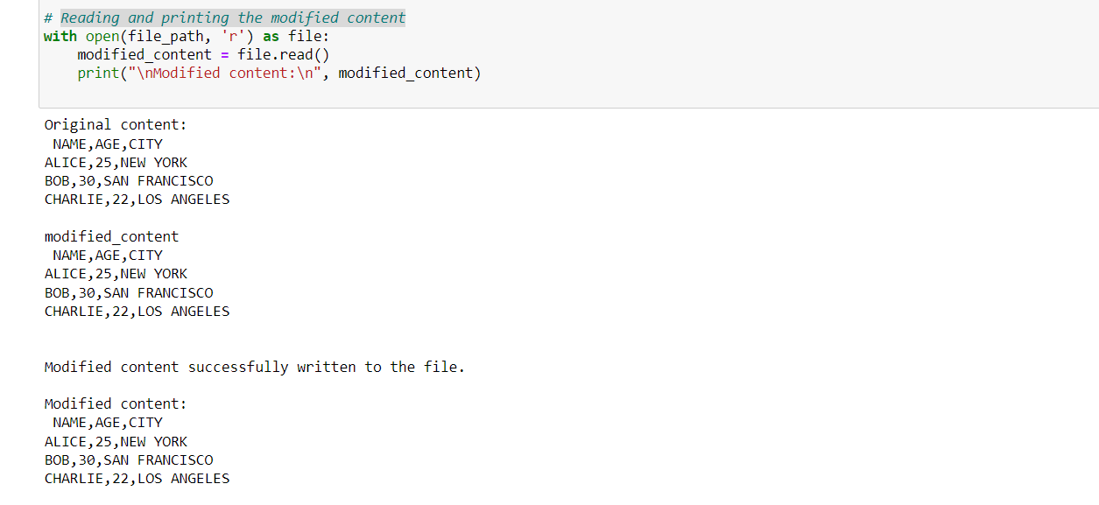

**Read data from csv file**

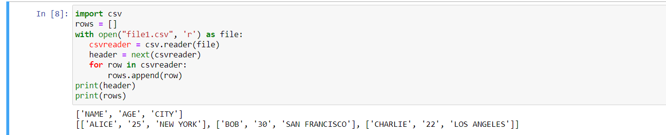

**Read file using file.readlines**

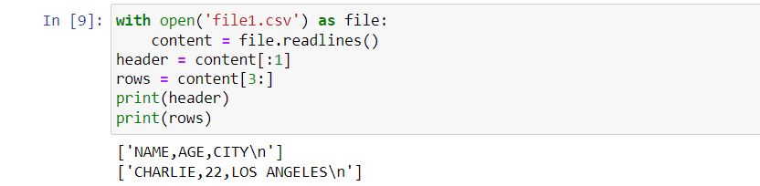

**Print an array using pandas and numpy**

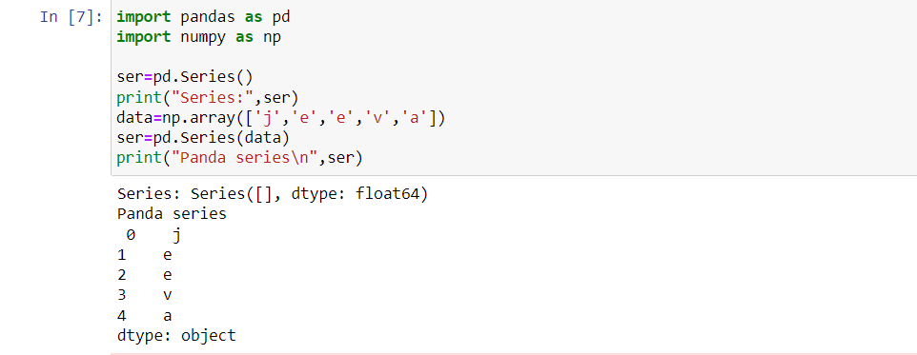

**Print a list using .DataFrame**

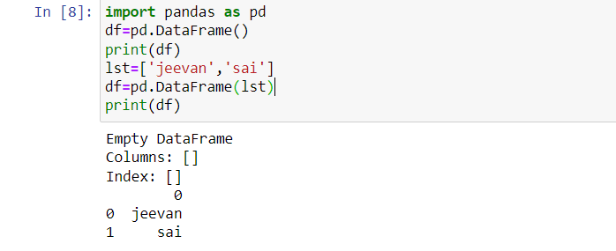

**Reading a csv file using pandas**

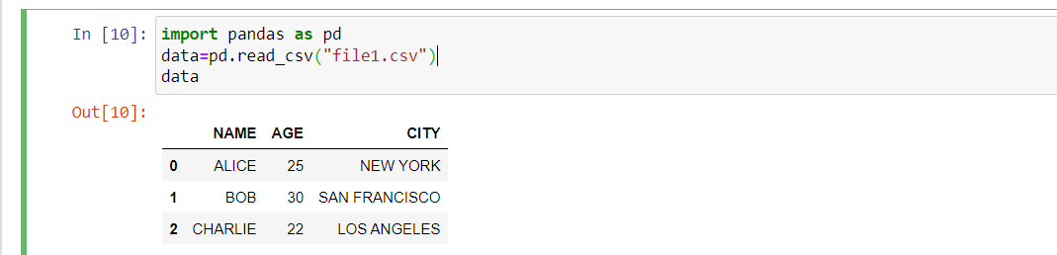

**Reading specific columns and data using pandas**

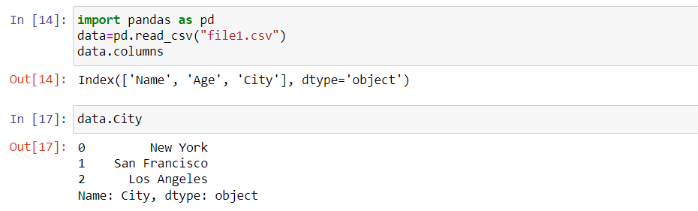

**Reading csv file using csv.DictReader**

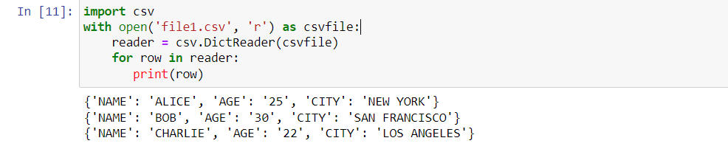

**Writing csv file using csv.writer and print written file**

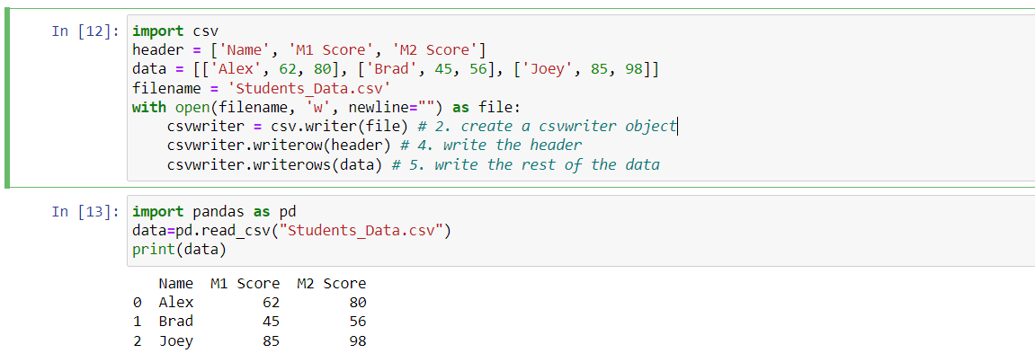

**Writing csv file using file.write**

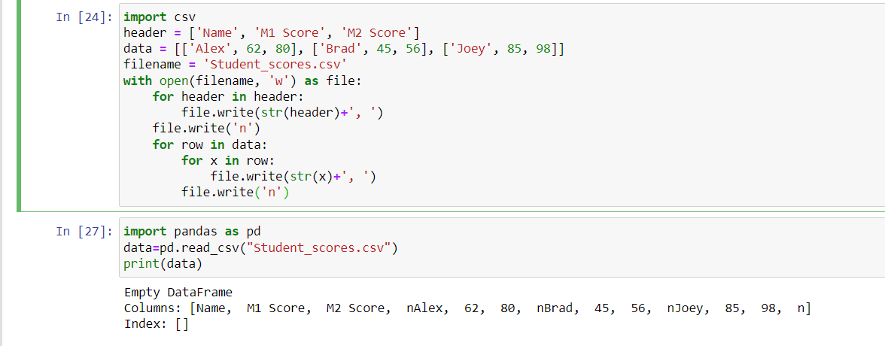

**Processing python lists**

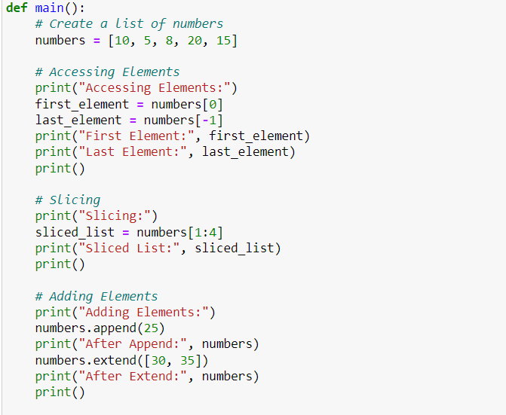

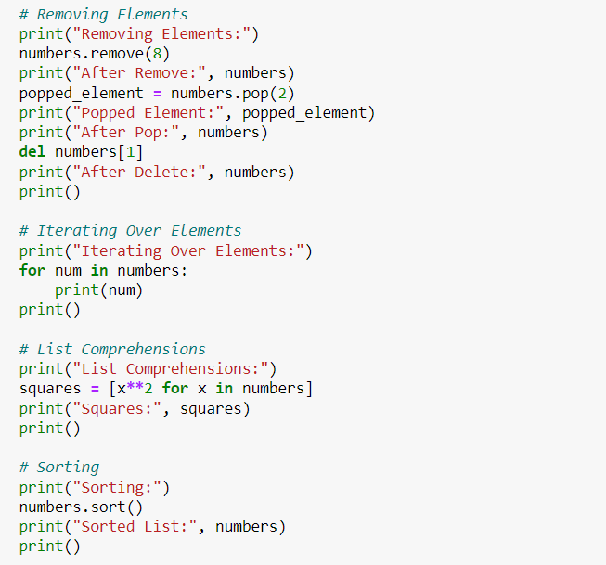

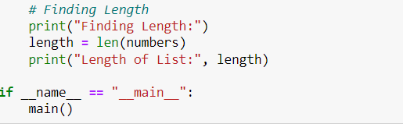

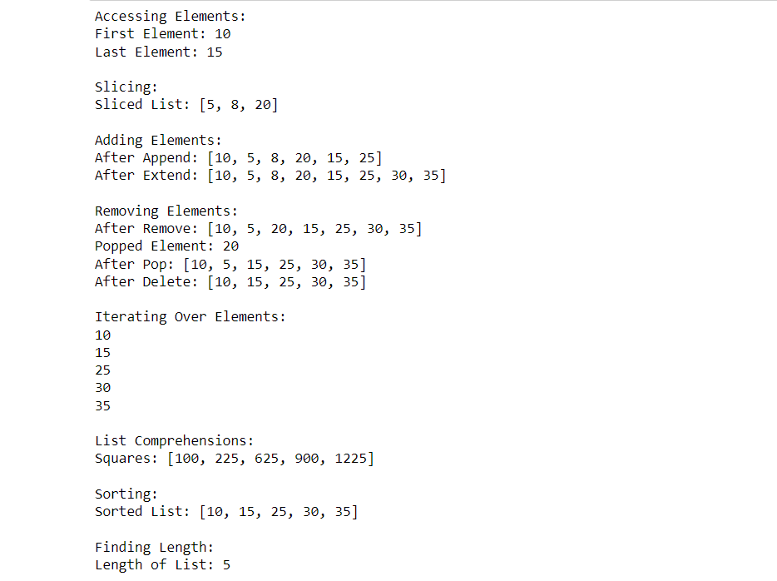

**Lambda functions in python with mapping**

